109062318簡弘哲

1. Producer running & semaphore changes

According to .map file, the address of _Producer is 0014, so I set a breakpoint there. Red block corresponds to the variable initialization ch=’A’, and blue block is the assembly code of SemaphoreWaitBody and decrease Semaphore ‘empty’ (addr = 22H) by 1

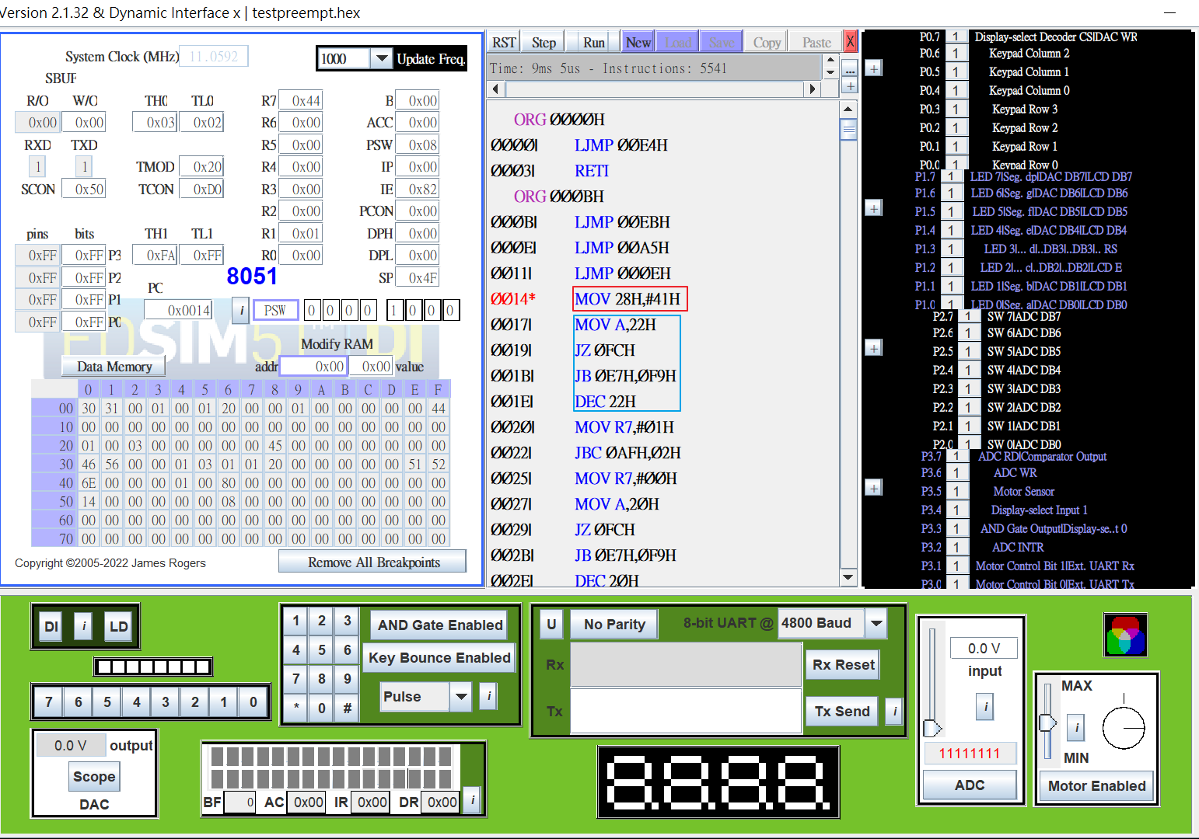

1. Consumer running & semaphore changes

According to .map file, the address of _Consumer is 005B, so I set a breakpoint there. Red block corresponds to the initialization of TMOD, TH1…, and blue block is the assembly code of SemaphoreWaitBody and decrease Semaphore ‘full’(addr = 21H) by 1

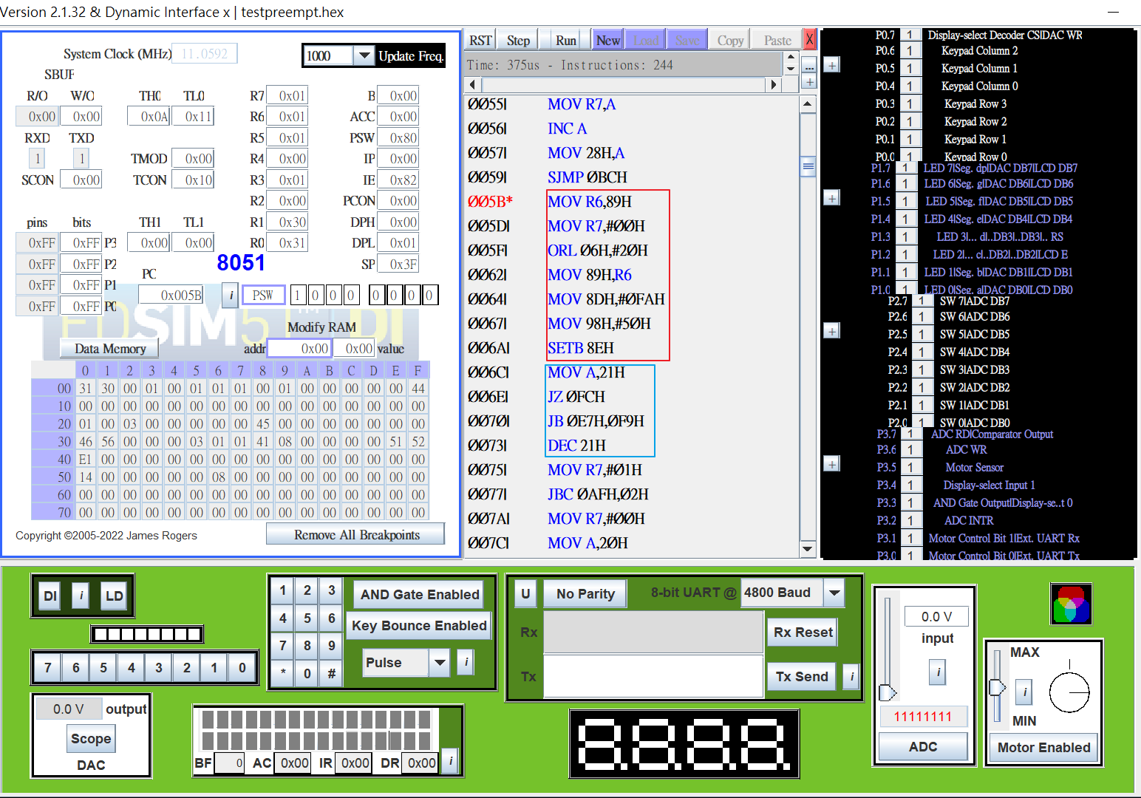

1. Typescript

